To-do list(using Sqlite)
Workshop #2
Flutter Developer Bootcamp

Purpose
This workshop demonstrates how to integrate SQLite database functionality into a Flutter application for storing, retrieving, updating, and deleting data. It's a practical example for developers looking to implement database operations in their Flutter apps.

Problem
In the given workshop, there will be a TodoList app containing a FloatingActionButton for adding data. You need to create a new task field for adding data instead of the FloatingActionButton, and add update and delete options for each data entry.

How to Solve
1. Checkout the workshop from Git Repo:
git clone -b <user-branch> <repo-URL>
2. Open the root folder inside VS Code
3. To build the app click the run option in the main method{}
4. Create the text field ‘ new task’
5. Additionally create update and delete option for each data entry.
6. Go To File: <specific-file-with-to-do list-method> à <method-name>, implement your logic.

You will Achieve
When you complete this workshop you will learn the following:
- SQLite Database Integration:
- The code integrates the SQLite database functionality into a Flutter application to store and manage data.
- UI Components:
- The UI is built using various Flutter widgets:
- Scaffold: Provides the basic structure for the app.
- AppBar: Displays the app bar with the title and delete action button.
- ListView.builder: Renders a scrollable list of items.
- ListTile: Represents each item in the list with options for deletion and update.
- FloatingActionButton: Provides a button to add new items.
- Dependencies:
- The code imports dependencies from two external packages:
- sqlite: For working with SQLite databases in Flutter.
- path: For handling file paths.
- Database Operations:
- The _initDatabase() method initializes the SQLite database and creates a table named 'items' with columns 'id' and 'name'.
- The _fetchItems() method retrieves items from the database and updates the _items list.
- The _addItem() method inserts a new item into the 'items' table.
- The _updateItem(int id) method updates an existing item in the 'items' table.
- The _deleteItem(int id) method deletes an item from the 'items' table.
- UI Customization:
- The app's theme is set to use the primary color swatch of blue.
- The app bar's color is customized to orange.
- Icons for delete and add actions are provided.

Screenshots

Before implementation (without Textfield and CRUD operation)

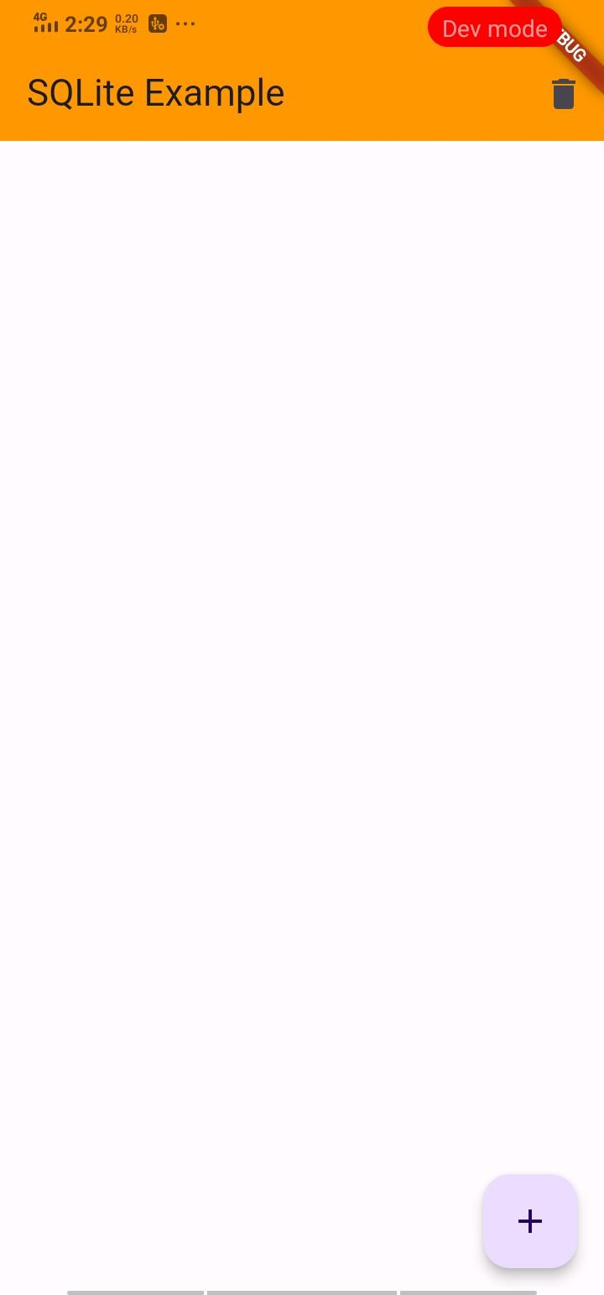

After implementation (With Textfield and CRUD operation)

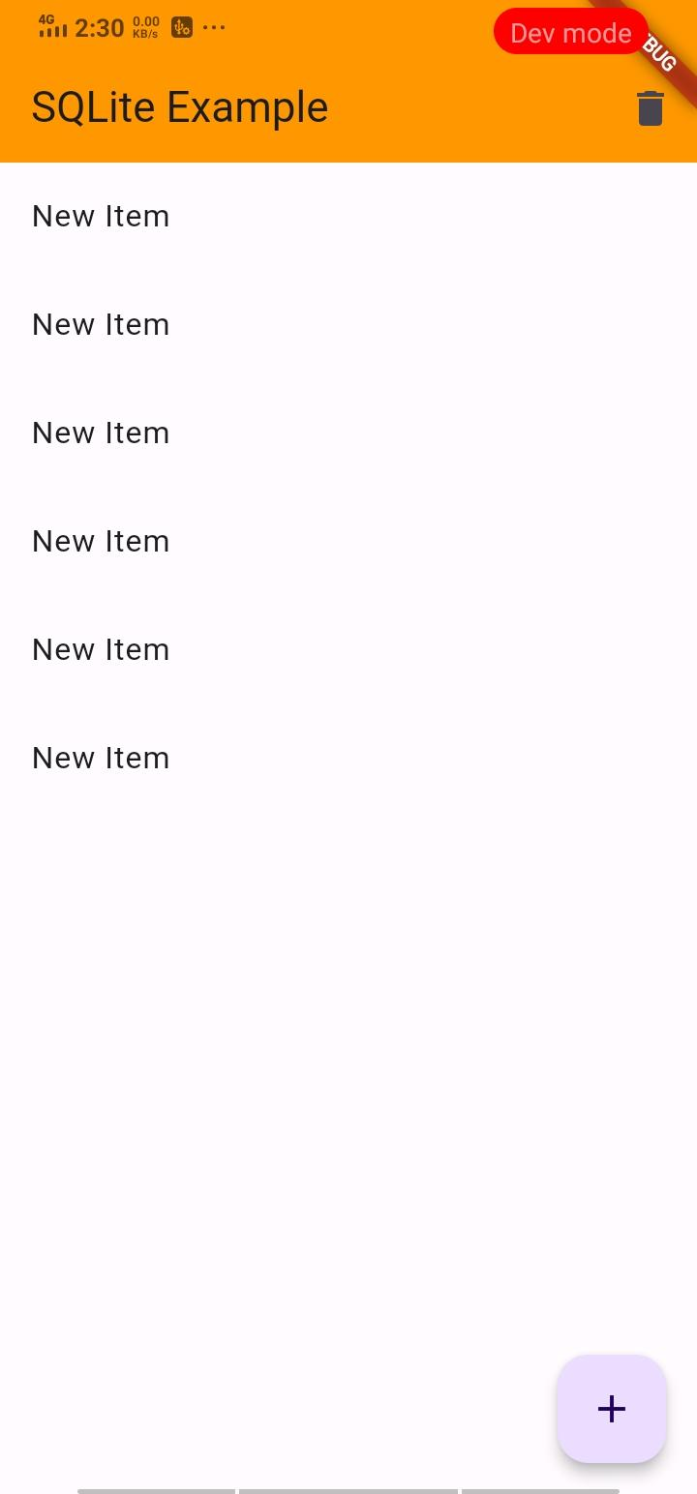

How to submit your workshop
Push your project back to the same git branch using command:
<command name>

Happy Coding!

